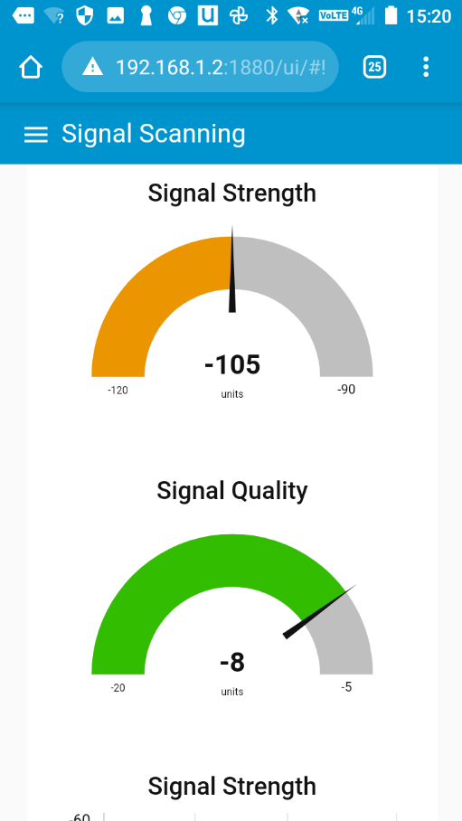
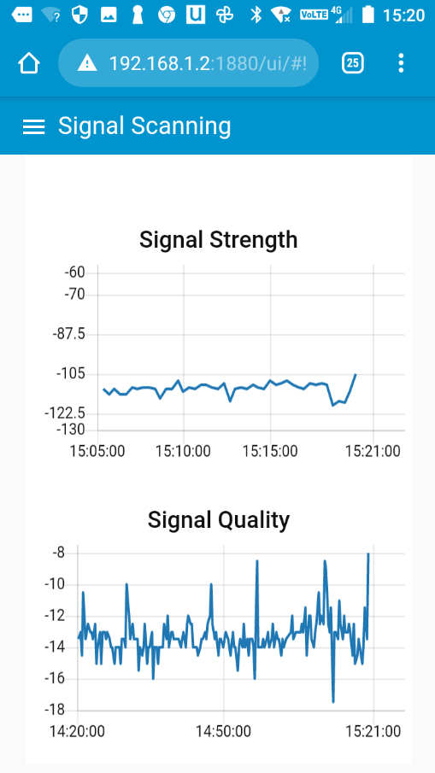

Quick Start Guide
Signal Explorer

Connected IoT
sales@connected-iot.com.au
www. connected-iot.com.au
Connected IoT signal explorer quick start guide 202205rv01

Introduction
The Signal Explorer is available in two versions:
SignalExplorer – 4G/3G | Frequencies Supported  4G/LTE: Bands 3, 5, 8, 28  (1800, 850, 900, 700 MHz)  3G/UMTS: Bands 1, 5, 8  (WCDMA/FDD 2100, 850, 900 MHz)
SignalExplorer – 4G/3G & CatM/NBIoT | Frequencies Supported  4G/LTE: Bands 3, 5, 8, 28  (1800, 850, 900, 700 MHz)  3G/UMTS: Bands 1, 5, 8  (WCDMA/FDD 2100, 850, 900 MHz)  CatM/NBIoT 12a/28/13/20/ 26b/8/3c /4/25d 1 (roaming only)

Two SIMs are required for the Signal Explorer – 4G/3G & CatM/NBIoT unit.

SIM Insertion
For the SignalExplorer to work the SIMs used must be active and appropriately provisioned for data and SMS. ALWAYS INSERT SIMs WITH THE POWER TURNED OFF

Battery ON/OFF Switch and Battery Operation
The Battery ON/OFF switch connects the battery to the 4G/3G gateway; however, the internal charge controller will disconnect the battery if the battery voltage drops below 10.8V and will not allow reconnection of the load until the voltage rises to above 11.8V.
If the battery needs charging a power supply should be within the limits of 15-24VDC and be capable of delivering at least 65W. Optional car charger is available as an accessory.

Wi-Fi ON/OFF
This switch connects or disconnects 5V power to the internal Wi-Fi access point. You can use this to attempt to reset the access point or to save power. In some cases, you may need to remove external power and turn OFF then ON - both the battery and the Wi-Fi switches if you are having issues accessing the device. Note that it can take 2-3 minutes for the WiFi the device to re-set and the dashboards to be accessible.

CatM/NBIoT ON/OFF Switch (if fitted)
Allows you to power down the CatM/NBIoT device if not being used.

Initiate Test Push Button
This button, in combination with the settings in the settings Tab allows for initiation of a signal test sequence, useful for testing when you want a simple test with LED indication of test success or failure. An SMS can be programmed to send test results to user.

LEDs
LEDs indicate state of signals and Test (See Initiate Test Push Button, above). Note that it takes some 10-15 seconds for the test LED to start indicating that a test is underway.

Connecting
The Signal Explorer is designed to be connected to via Wi-Fi – the unit includes a basic Wi-Fi router operating in Access Point mode. Wi-Fi connection details are on the label inside the lid of the unit.
When using a phone to connect the phone may ask whether to stay connected as the network has “no Internet access…” you should answer yes to this. On PC open browser 192.168.1.2:1880/ui
It is also possible that you may have to “Forget” the network. Switch off then on your W-Fi then re-enter details to ensure correct connection (depending on your phone).
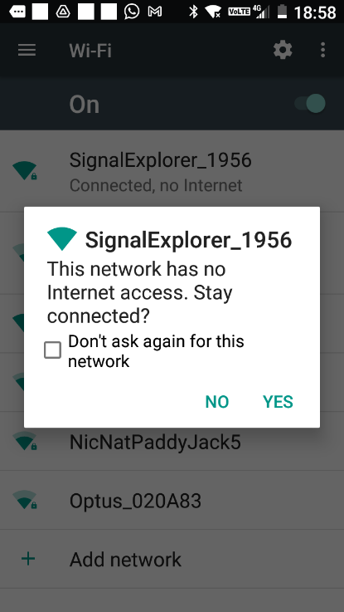

Logging into Dashboard
Once Wi-Fi is connected – then you can use the link, see QR code on inside of unit label to access the Monitoring Dashboards, you will be asked upon access the link, for a username and password.
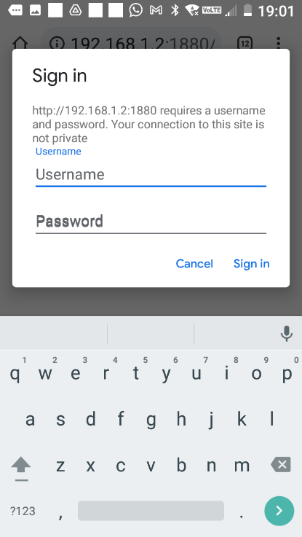

Basic Monitoring & Navigation
Once you have logged on to the Monitoring Dashboard the initial screen will show signal details for 4G/3G, additional Menu items are located under the three horizontal line icon in the top left.
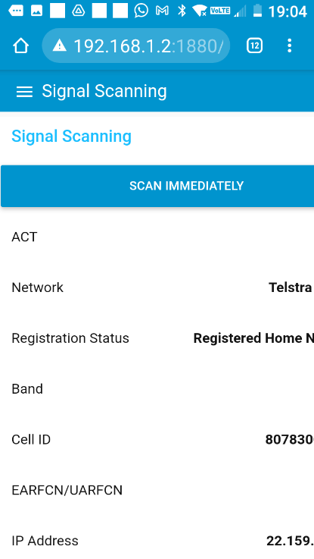
When using the SignalExplorer and clicking buttons or making settings be patient, in some cases multiple commands are taking place based on a setting or button click, and these changes may require a wireless module reset which can take 30-60 seconds.

To change SIM details, e.g., APN, username and Password go to the “SIM Configuration” page.
For CatM/NBIoT signal data (if applicable) go to appropriate pages.
Pages marked “Advanced” should only be used by users with a sound knowledge of cellular wireless module operation and associated AT Commands.
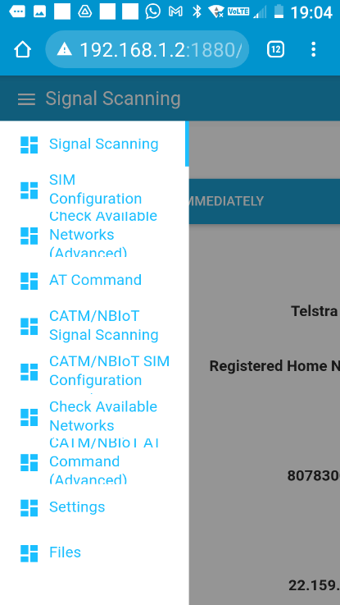

SIM Configuration
The “Check APN, Username and Password” button will perform a check of the current settings for the device (4G/3G or CatM/NBIoT, as applicable).
This check may take 15-30 seconds – be patient.
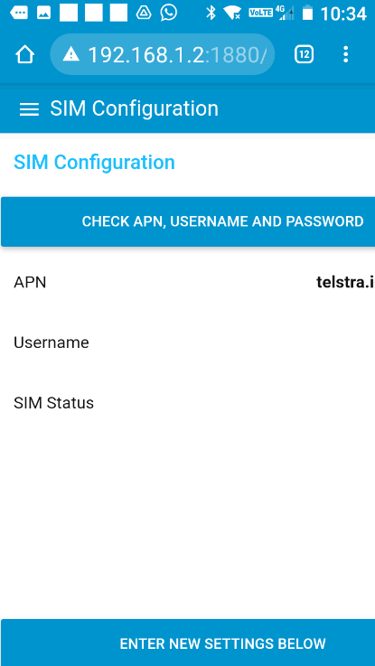
New APN, username and password settings can be made. After making these settings wait 20-30 seconds before trying to use any other features as it takes some time for the device to re-connect after making the settings
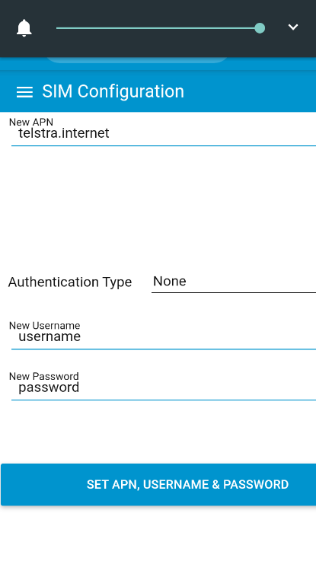

Settings
Signal Scan Rate – sets interval between scans for both 4G/3G and CatM/NBIoT.
Set Test Button/LED – links test button and associated LED to either 4G/3G or CatM/NBIoT unit.
No. of Scans For – Sets the number of scans to perform, for test to be successful all scans must pass minimum levels set below.
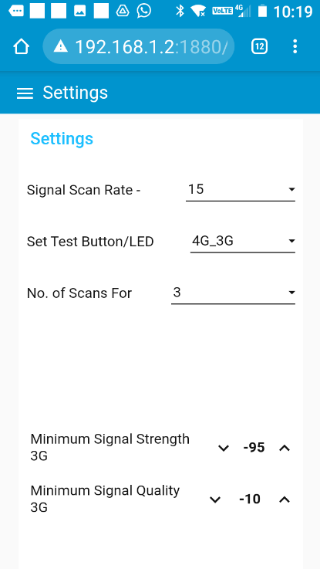
You should set appropriate minimum levels for both Signal Strength and Signal Quality.
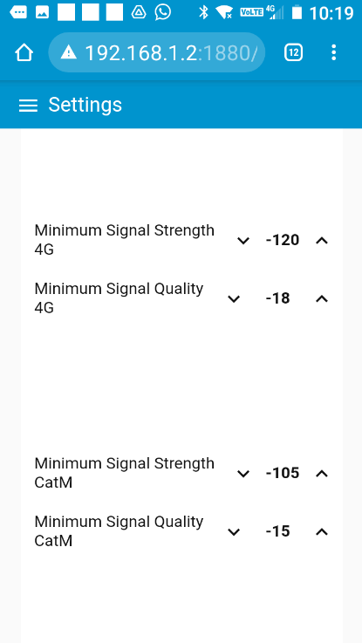

If an SMS number, with format YYXXXXXXXXX where
YY is country code (do not use the + indicator)
XXXXXXXXX is the mobile number
…is set and it is enabled then the result of the test will be SMS to that phone number. The SMS function uses the 4G/3G device and as such if this device is not connected an SMS will not be sent.
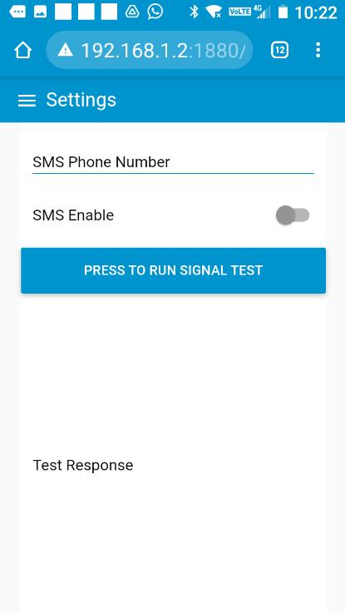
If an Email Address is set, and is enabled, then the result of the test will be Emailed to the address entered. The Email function uses the 4G/3G device and as such if this device is not connected with an active IP connection the Email function will not work.

Files
It is possible to download a file containing signal data to excel for analysis/plotting etc. A new file is created every month. Old files can be deleted.
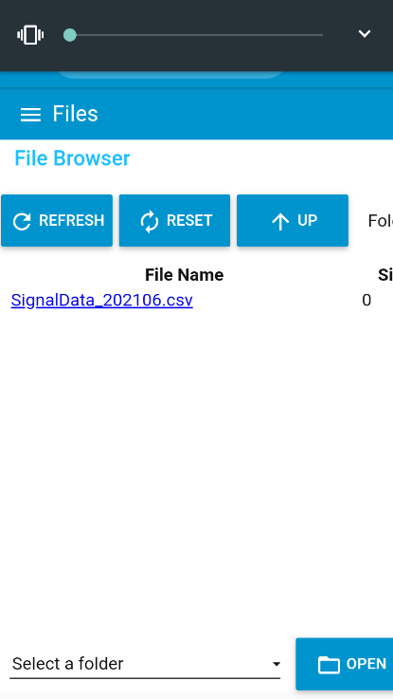
For further assistance contact the supplier.

Setting Radio Band for 4G/3G
It is possible to lock the unit to specific Radio Bands for 3G and/or 4G, only experienced users should do this as locking the radio band may cause the unit to be unable to find a connection in certain circumstances.
ACT/Network | Band | Command
3G | 1 | AT^SCFG="Radio/Band/3G","0x00000001"
 | 5 | AT^SCFG="Radio/Band/3G","0x00000010"
 | 8 | AT^SCFG="Radio/Band/3G","0x00000080"
 | All Bands (Default) | AT^SCFG="Radio/Band/3G","0x00000091
4G | 3 | AT^SCFG="Radio/Band/4G","0x00000004"
 | 5 | AT^SCFG="Radio/Band/4G","0x00000010"
 | 8 | AT^SCFG="Radio/Band/4G","0x00000080"
 | 28 | AT^SCFG="Radio/Band/4G","0x08000000"
 | All Bands (Default) | AT^SCFG="Radio/Band/4G","0x08000094"

Taking Screenshots of Signal Data
It is impracticable to take screenshots of the display from a phone – a better way to record this information is to print/save/or send as .pdf. The example below is based on an android device however it can also be done on an iPhone.
- Click/Tap on the Icon at top right of screen
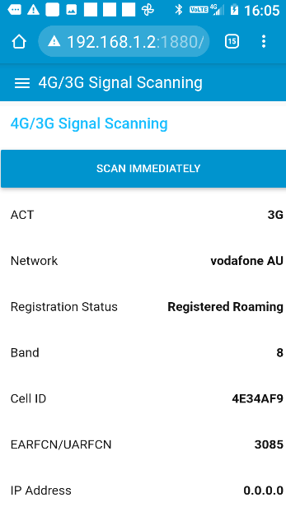
- Select Share
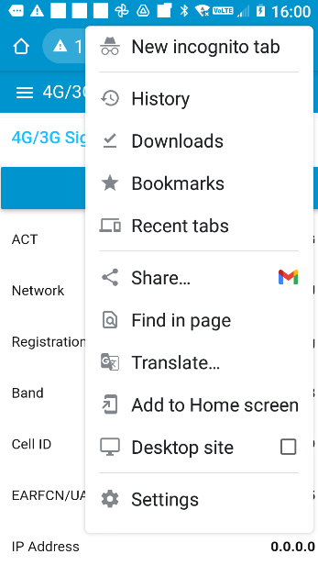

- Choose Print (or send as PDF depending on phone)
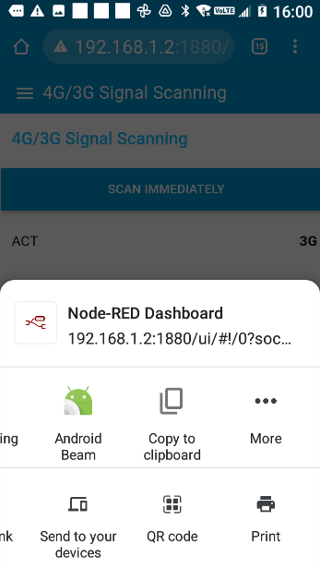
- Set Options and Print or Send, if printed then document can be emailed using your email program
